EC Declaration of Performance | 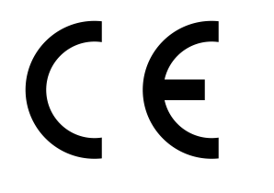

The Producer

Lime Green Products Ltd
Coates Kilns
Stretton Road
Much Wenlock
Shropshire
TF13 6DG

Declares that the product

Lime green Natural Lime Mortar - Strong

Manufactured at

Coates Kilns
Stretton Road
Much Wenlock
Shropshire
TF13 6DG

Complies with the provisions of EN998-2 2010 and fulfils the conditions for CE marking in accordance with EN998-2 2010.

Evaluation of conformity has been carried out according to the procedures in table ZA.1

The product has undergone initial type testing and is subject to system 4 factory production control as specified in EN998-2.

J Ayres

Director

Lime Green Products Ltd, Coates Kilns Stretton Road, Much Wenlock, Shropshire, TF13 6DG

14

EN 998-2 2010
Natural Lime Mortar - Strong
Prescribed general purpose mortar for internal and external use

Proportion of constituents (by volume):
Hydraulic Lime (HL5) 1
Aggregates 2.5

Reaction to fire | A1
Water absorption kg/(m².min^{0.5)} | 1.19
Water vapour permeability µ | 15/35
Thermal conductivity W/mK | P=50% 0.83
Durability | Evaluation based on provisions valid in the intended place of use of the mortar

